Creating database in cmd

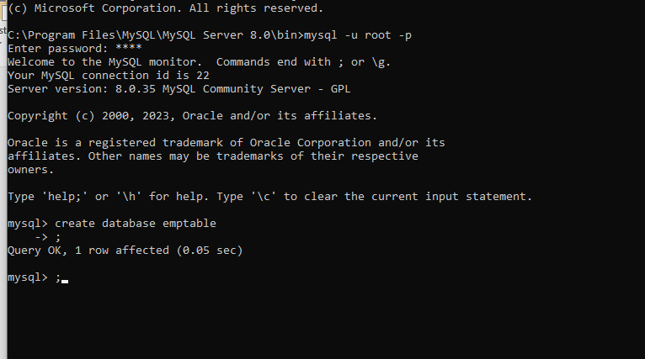

Creating table in database “demotest”

Use command to get into the database

Create table table_name(table structure) command to create a table in database

Insert into table_name(table structure) values() command to insert values into table

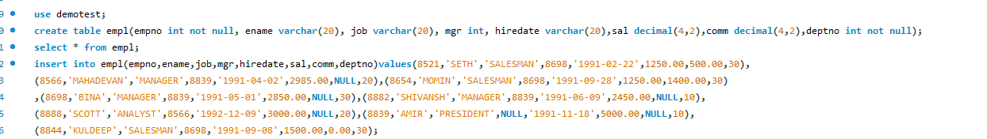

Select*from table_name to display all table contents

Select*from empl

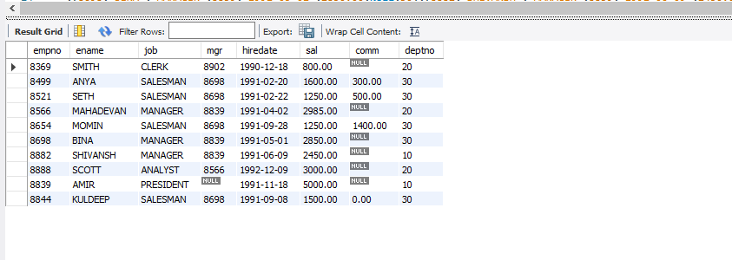

To display values where salary is greater than equal to 2200

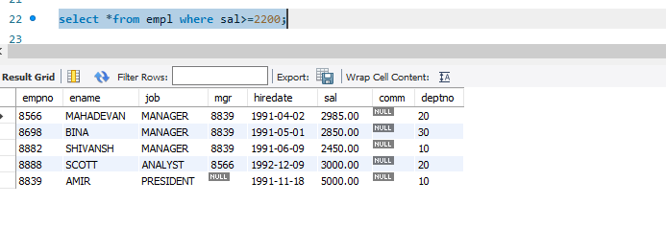

To display values of employees who are not getting commission

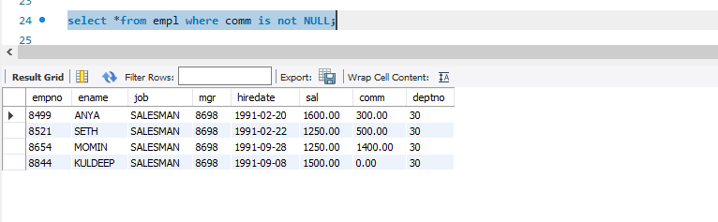

To display salary of between the range 2500 and 4000

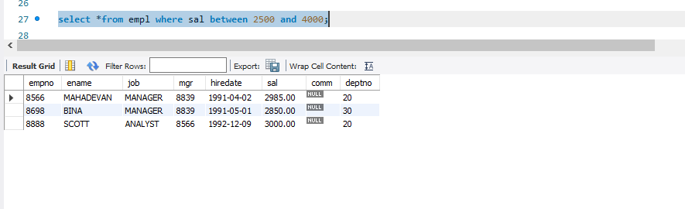

To display values of employees who don’t have a manager

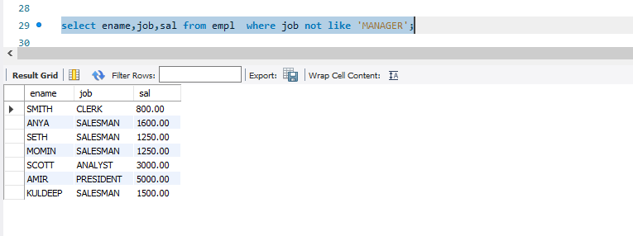

To display values of employee name whose name contains ‘A’ as third alphabet

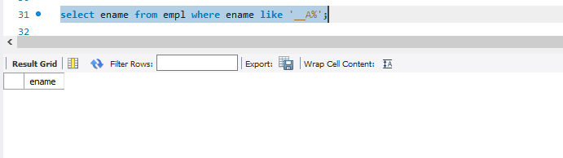

To display values of employee name whose name contains ‘T’ as last alphabet

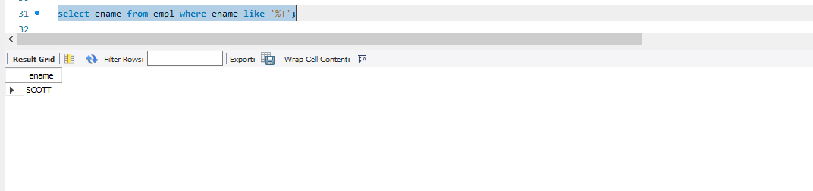

JDBC connectivity:



Table created

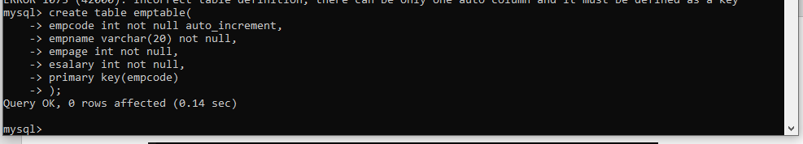

Values inserted into tables through JDBC connectivity

